1.Create a Kanban Board to Visualize the Tasks.
- Create Columns for To Do, In-Progress and Done.
- Add Atleast 5 Sample Tasks
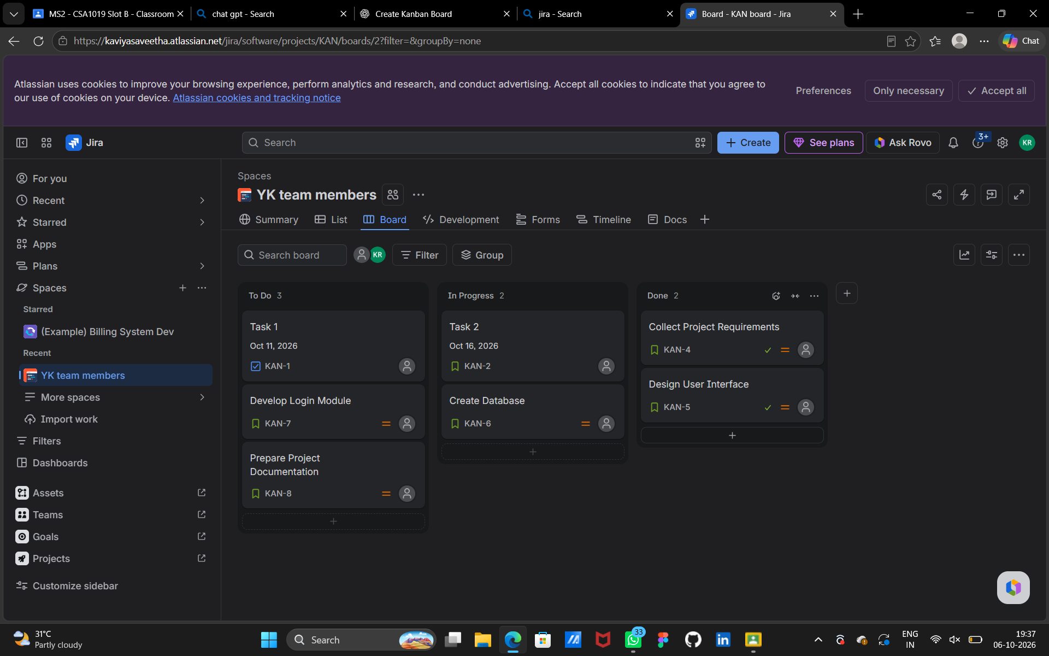
- Move the Tasks across the Columns to Simulate the Workflow.

